**Please Note :- In Employee.csv file**

- Employee.csv file row 10 problem only not loading in mysql workbench details as follows:-

'9' ,'Madan' , 'Mohan', 'Senior General Manager' ,'L7' ,'26-01-1961 00:00' ,'14-01-2016 00:00' '1008 Vrinda Ave MT' , 'Edmonton' ,'AB' , 'Canada' , 'T5K 2N1', '+1 (780) 428-9482', '+1 (780) 428-3457' ,'madan.mohan@chinookcorp.com'

**Question Set 1**

1. Who is the senior most employee based on job title?

select * from employee

where levels = 'L6';

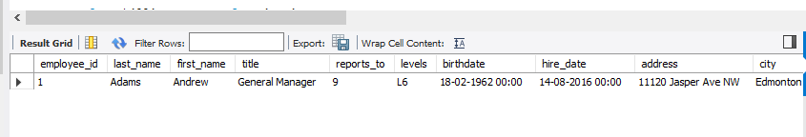

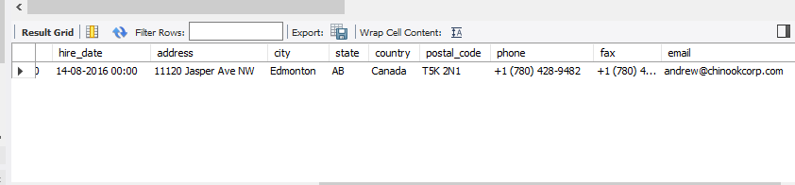

2. Which countries have the most Invoices?

select billing_country from invoice

group by billing_country

order by billing_country desc

Limit 1;

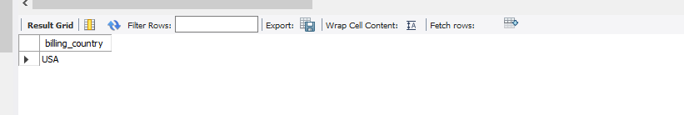

3. What are top 3 values of total invoice?

select max(total) from invoice

group by total

order by max(total) desc

limit 3;

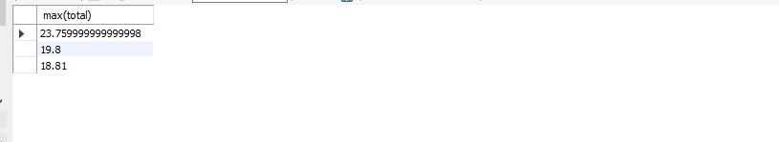

4. Which city has the best customers? We would like to throw a promotional Music Festival in the city we made the most money. Write a query that returns one city that has the highest sum of invoice totals. Return both the city name & sum of all invoice totals?

select billing_city,sum(total) from invoice

group by billing_city

order by sum(total) desc

limit 1;

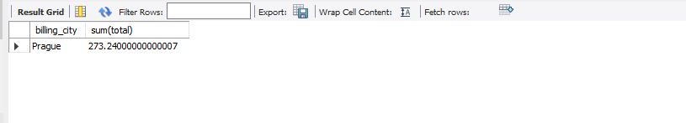

5. Who is the best customer? The customer who has spent the most money will be declared the best customer. Write a query that returns the person who has spent the most money?

select customer_id,first_name,last_name from customers

where customer_id = (select customer_id from invoice

group by customer_id

order by sum(total) desc

limit 1);

